**Documentation**

Speed up and Slow Down Video Clips In Camtasia 2020

1. My selected video is this one: <https://www.youtube.com/watch?v=EjkC1WcwHJ8&list=PLDyDYqoIde4B3pQdSSq_PE8E77_QbM46z&index=16>
2. The target users are people that use Camtasia 2020. Their level of competence for using Camtasia doesn’t need to be that high, as that video is a tutorial for beginners. However, their computer literacy should be at least average. The aim of this tutorial is to teach people how to speed up and slow down video clips using Camtasia 2020.
3. My short how-to guide:
4. Open your Camtasia 2020 program.
5. Choose the video clip you want to speed up or slow down.
6. Open the video clip in the *Media tab*.
7. Go to *Visual Effects*.
8. Drag the *Clip Speed* effect to your video, then open the effects’ tray.
9. Hover over the edge of the clip speed bar until you see these little arrows.

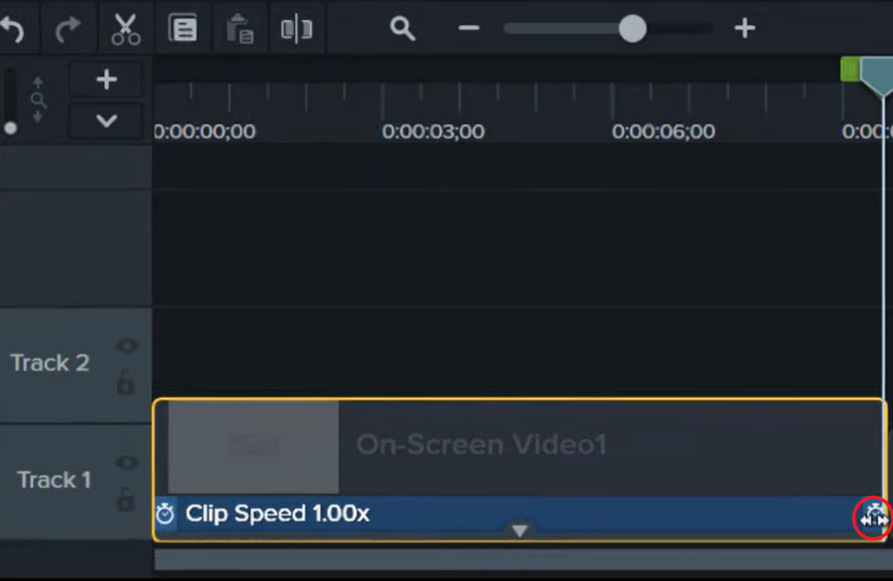

1. To speed the video clip up, drag it to the left.
2. To slow the video clip down, drag it to the right.